ESP 8266-01 Node

# Schematic

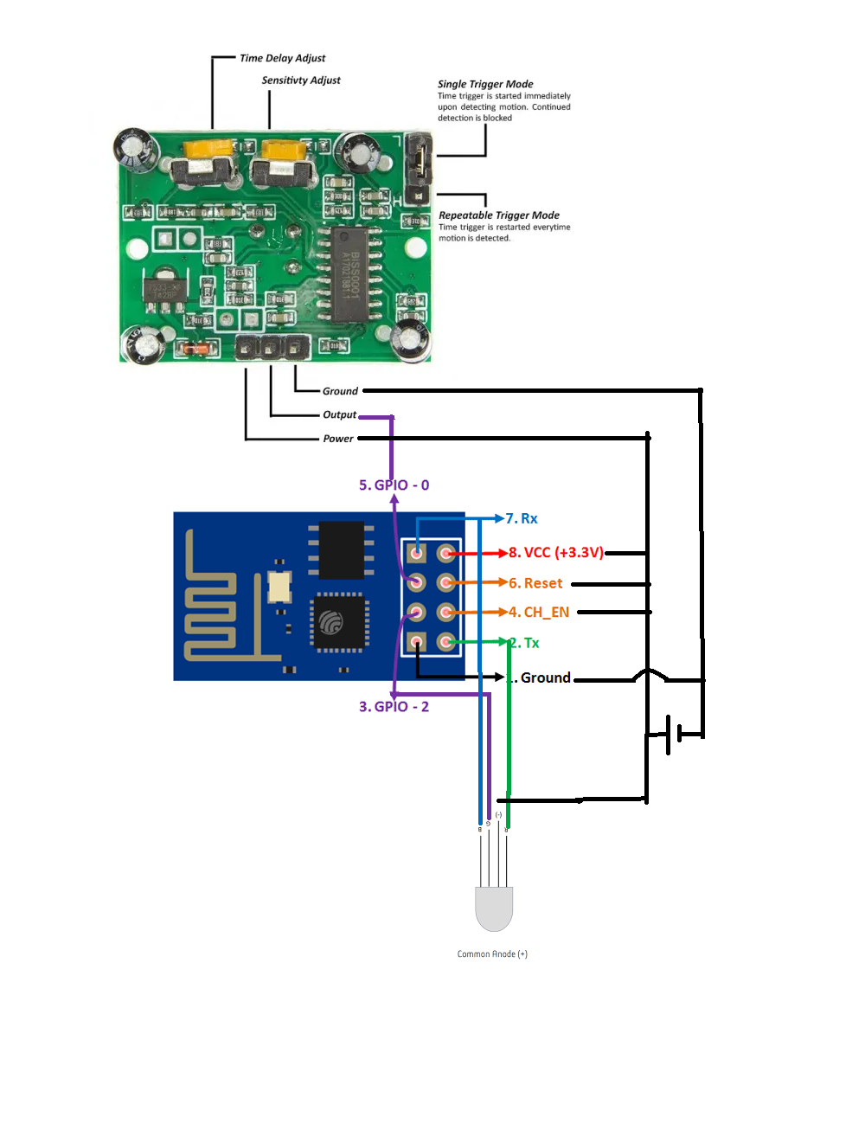

Note:

The ESP and IR sensor work at 3.3 volts.

This design shows the pins for the output to the led. A power LED with good visibility still has to be determined. You will probably need a different power source or make use of voltage dividers to hook it up as well as using a resistor to limit the current through the led.

# Esp 8266-01 information

The ESP8266-01 is the smallest ESP8266 module and only has 8 pins. Of these VCC, GND, RST (reset) and CH_PD (chip select) are not I/O pins but are needed the operation of the module. This leaves GPIO0, GPIO2, TX and RX available as possible I/O pins, but even these have pre-assigned functions. The GPIO0 and GPIO2 determine what mode the module starts up in and the TX/RX pins are used to program the module and for Serial I/O, commonly used for debugging. GPIO0 and GPIO2 need to have pull-up resistors connected to ensure the module starts up correctly.

You have to ground GPIO0 before programming!

# Things to Test/improve

Does the infrared sensor respond well enough in a gym environment?

What power LED has the required visibility?

Can a WIFI library be found that can support more than 8 nodes.